Excel Assignment 1

1. What is Excel? Why do we use Excel?

Microsoft Excel is a spreadsheet developed by Microsoft for Windows, macOS, Android and iOS. It features calculation or computation capabilities, graphing tools, pivot tables, and a macro programming language called Visual Basic for Applications (VBA). Excel forms part of the Microsoft Office suite of software.

It is the number one platform when it comes to analyzing data, finding information, preparing charts, and presenting them to decision-makers. Excel performs well for all levels of user—from the basic calculator to the 100% technically adept—and allows each user to feel accomplished.

1. List all the versions of Microsoft excel. Compare excel software provided from multiple vendors.

Versions of Microsoft excel :--

[Excel 365](https://thesmartmethod.com/excel-versions-explained/#365)  
[Excel 2021](https://thesmartmethod.com/excel-versions-explained/#2021)  
[Excel 2019](https://thesmartmethod.com/excel-versions-explained/#2019)  
[Excel 2016 and 365](https://thesmartmethod.com/excel-versions-explained/#2016)  
[Excel 2013 (Windows)](https://thesmartmethod.com/excel-versions-explained/#2013)  
[Excel 2011 (Mac)](https://thesmartmethod.com/excel-versions-explained/#2011)  
[Excel 2010 (Windows)](https://thesmartmethod.com/excel-versions-explained/#2010)  
[Excel 2008 (Mac)](https://thesmartmethod.com/excel-versions-explained/#2008)  
[Excel 2007 (Windows)](https://thesmartmethod.com/excel-versions-explained/#2007)  
[Excel 2004 (Mac)](https://thesmartmethod.com/excel-versions-explained/#2004)  
[Excel 2003 (Windows)](https://thesmartmethod.com/excel-versions-explained/#2003)  
[Older Windows versions (2002, 2000, 97, 95, 4.0, 3.0, 2.0)](https://thesmartmethod.com/excel-versions-explained/#olderwindows)  
[Older Mac versions (2001, 2000, 98, 5, 4, 3, 2, 1)](https://thesmartmethod.com/excel-versions-explained/#oldermac)  
[OS/2 Versions (2.2, 2.3, 3)](https://thesmartmethod.com/excel-versions-explained/#os2)

1. How to create bar charts in excel, demonstrated with practical examples.

A bar chart is a graph that shows horizontal bars with the axis values for the bars displayed on the bottom of the graph. It is a graphical object used to represent the data in your Excel spreadsheet. You can use a bar chart when, You want to compare values across categories

To insert a bar chart in Microsoft Excel, open your Excel workbook and select your data. You can do this manually using your mouse, or you can select a cell in your range and press Ctrl+A to select the data automatically. Once your data is selected, click Insert > Insert Column or Bar Chart.

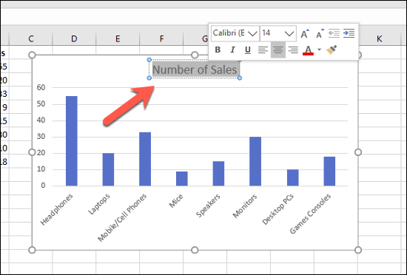

1. Create an analytics dashboard in python and present your findings.

1. How to connect Excel with the databases.

To connect Excel to a database in SQL Database, open Excel and then create a new workbook or open an existing Excel workbook. In the menu bar at the top of the page, select the Data tab, select Get Data, select From Azure, and then select From Azure SQL Database.